A vector quantization scheme using prequantizers of the human visual effects
Chun-Hung Kuo, Chang-Fuu Chen
Signal Processing: Image Communication, Vol. 12, No. 1, pp. 13-21, March 1998
Abstract
In this paper, a new human visual system is applied to the vector quantization (VQ) scheme.
- Introduction
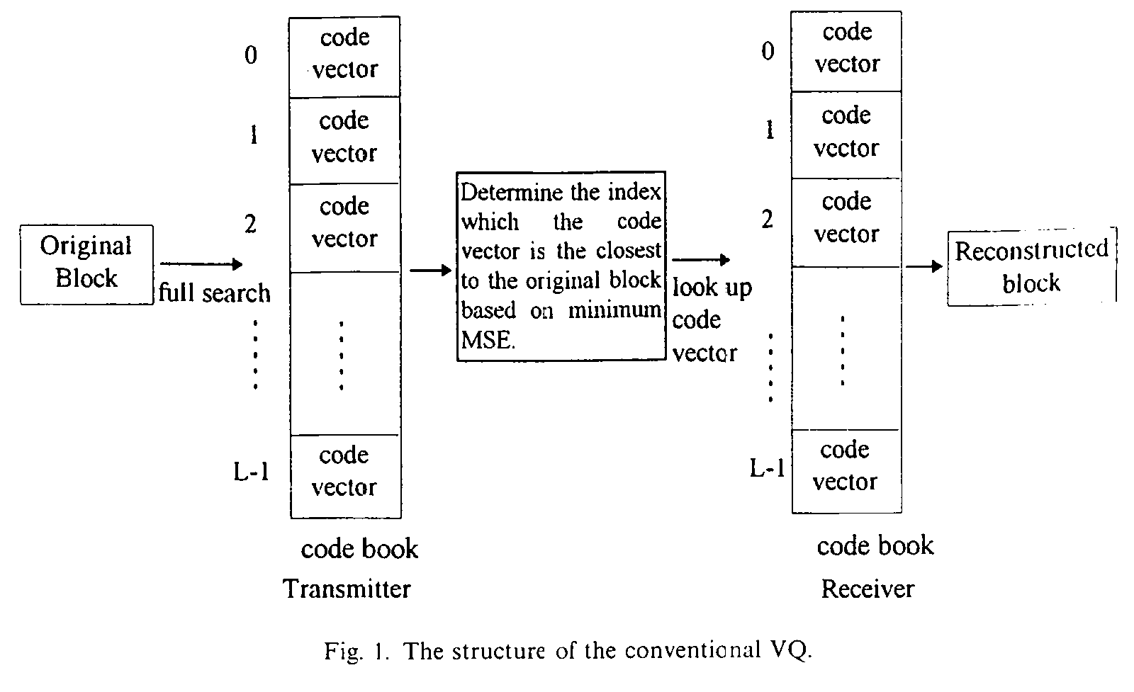
- The human visual model
The Weber’s law, visual masking effect, and Mach band effect show the human visual effect in the spatial domain.
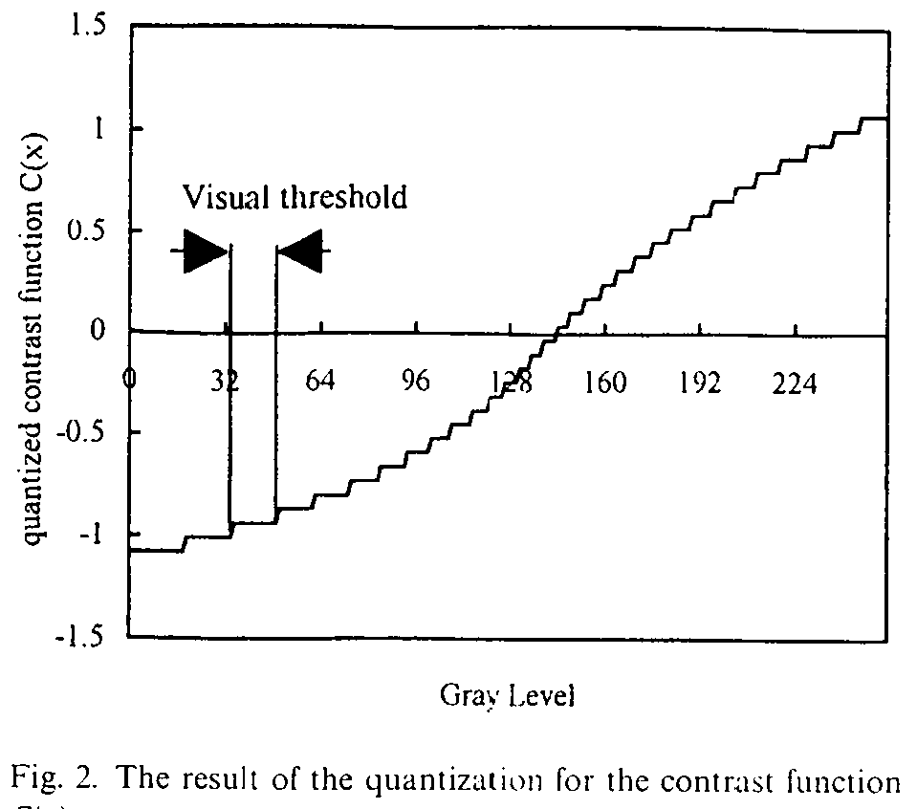
- The VQ with the human visual system

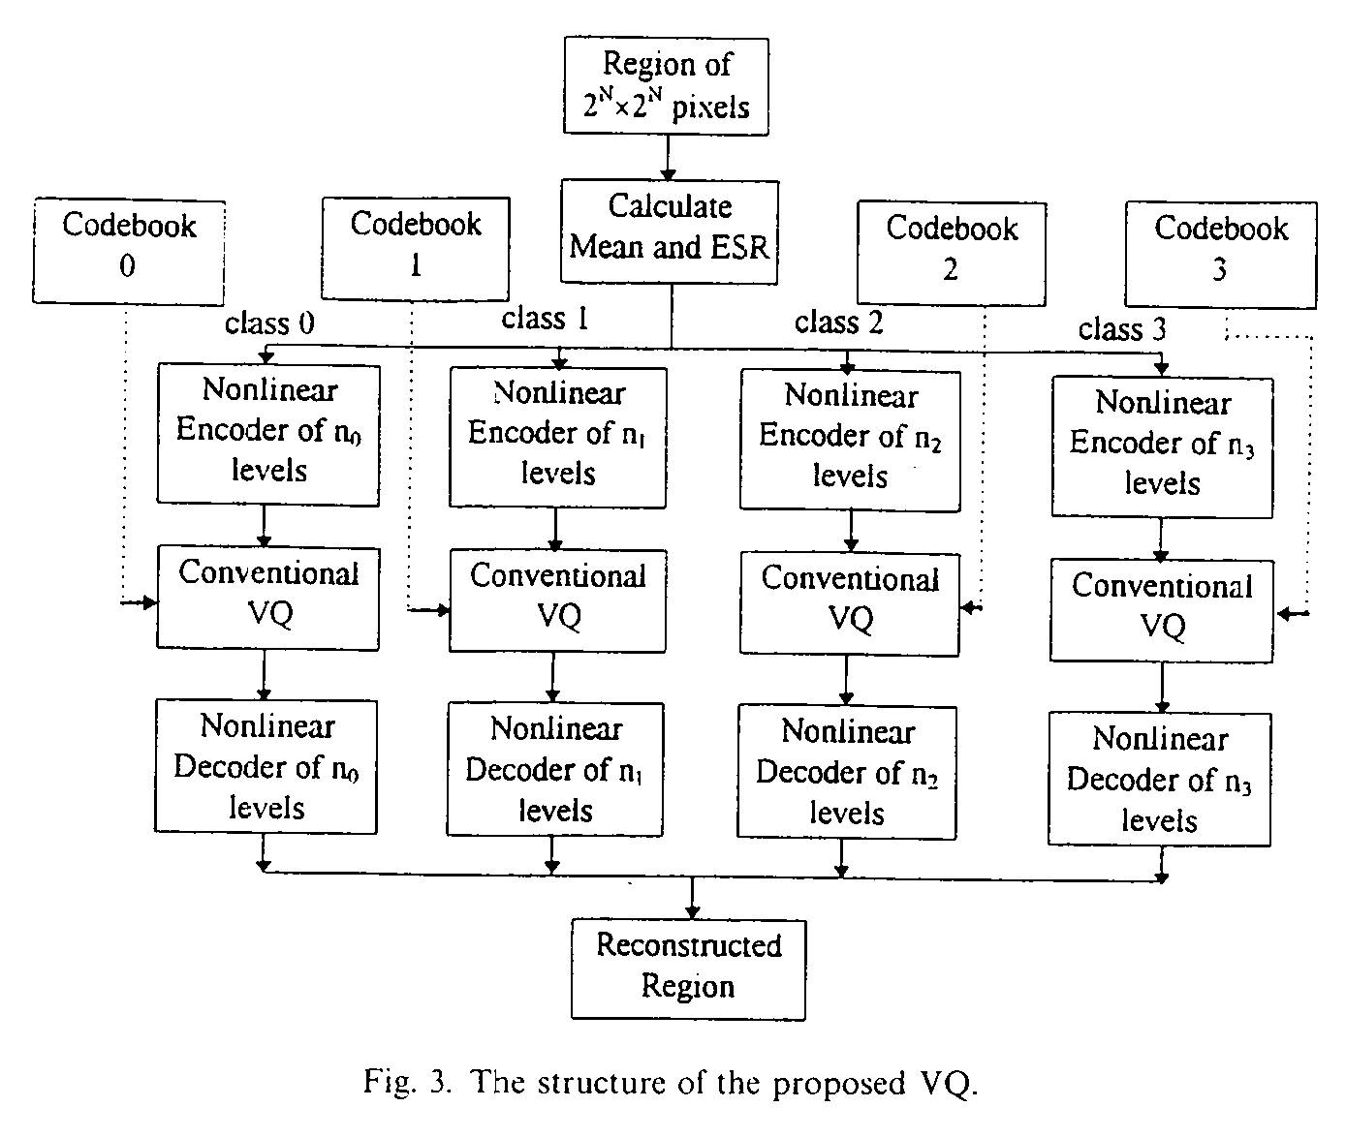
- Simulation

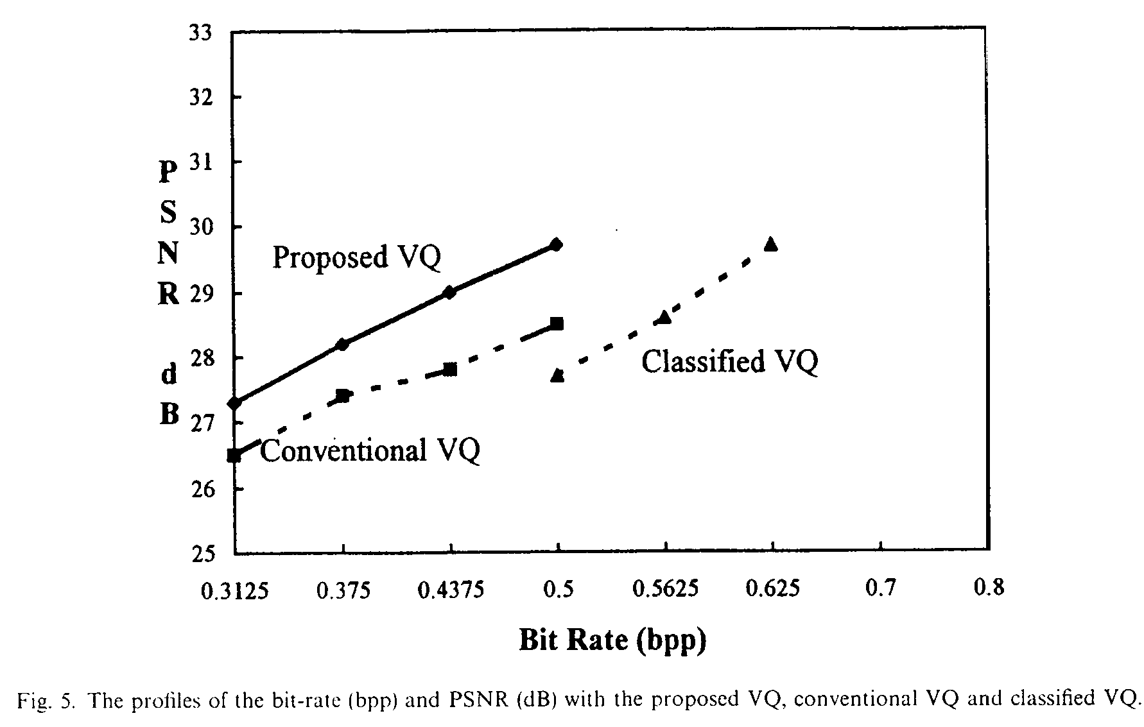
- Conclusion
The PSNR of the reconstructed image with the proposed VQ is better than those with the conventional VQ and classified VQ under the same bit-rate.
Created by : Chia-Hao Yang
Date : August 21, 1998

